♀29. Moon (Reflection) (MOON RIVER)-Track 33 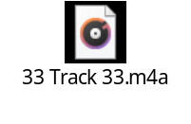
moon (moon) n.
1. the heavenly body that revolves around the earth from west to east once in c. 27 1/3 days with reference to the stars or once in c. 29 ½ days with reference to the sun, and that accompanies the earth in its yearly revolution about the sun, reflecting the sun’s light: the moon’s diameter is c. 2,160 miles, its mean distance from the earth is c. 238,857 miles, its mean density is c. 3/5 that of the earth, its mass is c. 1/81, and its volume c. 1/49 2. this body as it appears during a particular lunar month or period of time, or at a particular time of the month: see New Moon, Half-Moon, Full Moon, Old Moon, First Quarter, Last Quarter 3. a month; esp., a lunar month 4. same as moonlight 5. anything shaped like the moon (i.e., an orb or crescent) 6. any satellite of a planet—vi. [from the notion of behaving as if moonstruck] to behave in an idle, dreamy, or abstracted way, as when in love—vt. to pass (time) in mooning
moon·beam (-bēm’) n.
a ray of moonlight

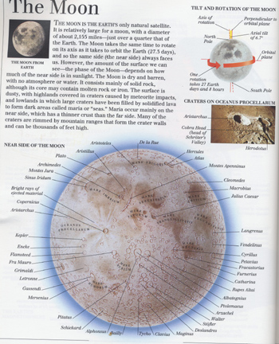

Fay Half-Told-Story Moon  Phase 1  Sill holds that winged death at bay  Till somber walks forget the day  When night comes down to greet me…  When night comes down to eat me.  Fay half-told-story moon  Delay a ghost of yesterday  Pray to hear, to end the end  To story-tell full moon. | Phase 2  Rotates moon  Revolves half-gate  To hold an earth-world’s  Wobbled (dumb-bell) revolution in testate  To hold still life of planet blue  To even change of now and then and when, anew  Dawn closes down to moonlight dim  And lifts the lids of rooster’s hen  To beat the grass green in sun’s gleeful baby bed  A minute maid-man. Amen  Pulls water full from high to low  Rotates moon  Revolves slow glow  Pulls water empty as  nows up and go
